Graphical Password Authentication

In this project you ask to develop login and signup using image based password where application will shuffle 25 images for every login and signup users to make password more secured. At any time valid user can reset his password if forgot.

To run project install Java1.8 or higher and then install Tomcat7.0 web server and then install MYSQL to save user password details. After installation copy content from ‘WEB_INF/database.txt and then paste in MYSQL console to create database

Put GraphicalPassword folder inside Tomcat WEBAPPS directory and then start tomcat server from bin folder. Now open browser and enter URL as ‘http://localhost:9999/GraphicalPassword’ and then press enter key to get below page

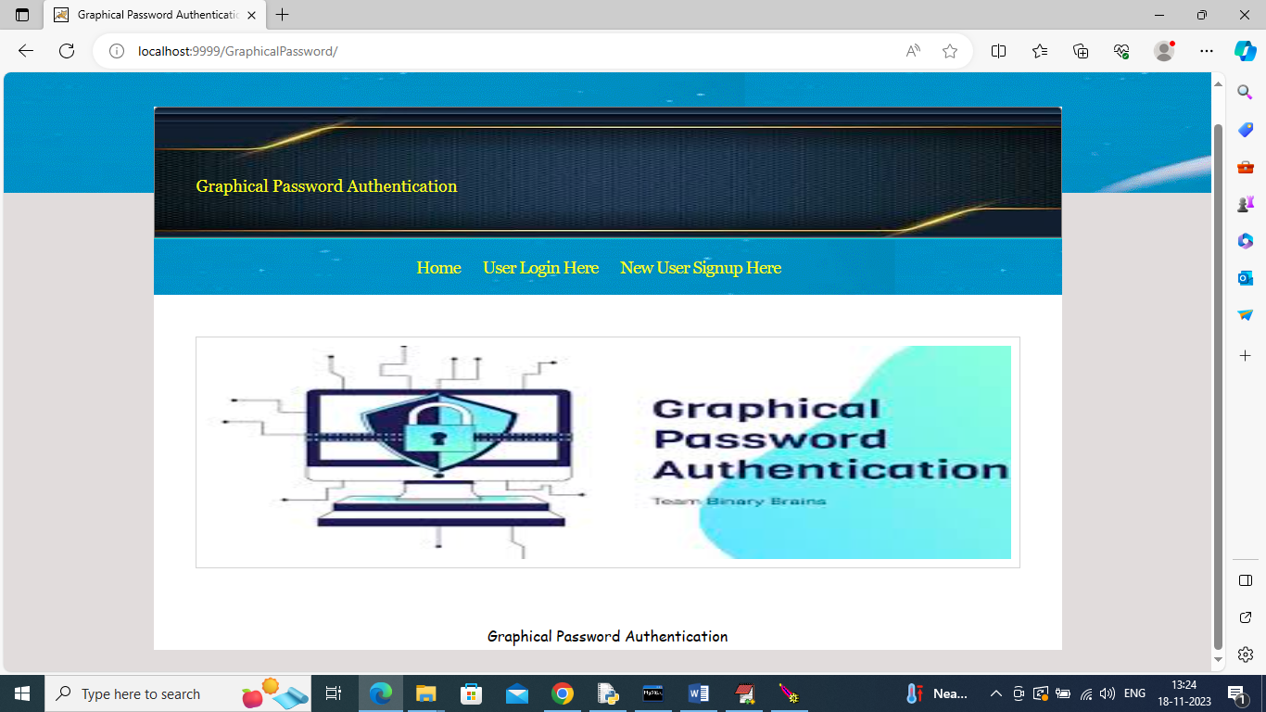

In above screen click on ‘New User Signup Link’ to get below signup page

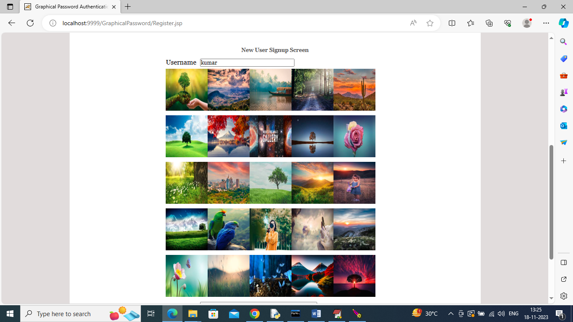

In above screen for signup user can enter username and then click on desired image to get password like below screen

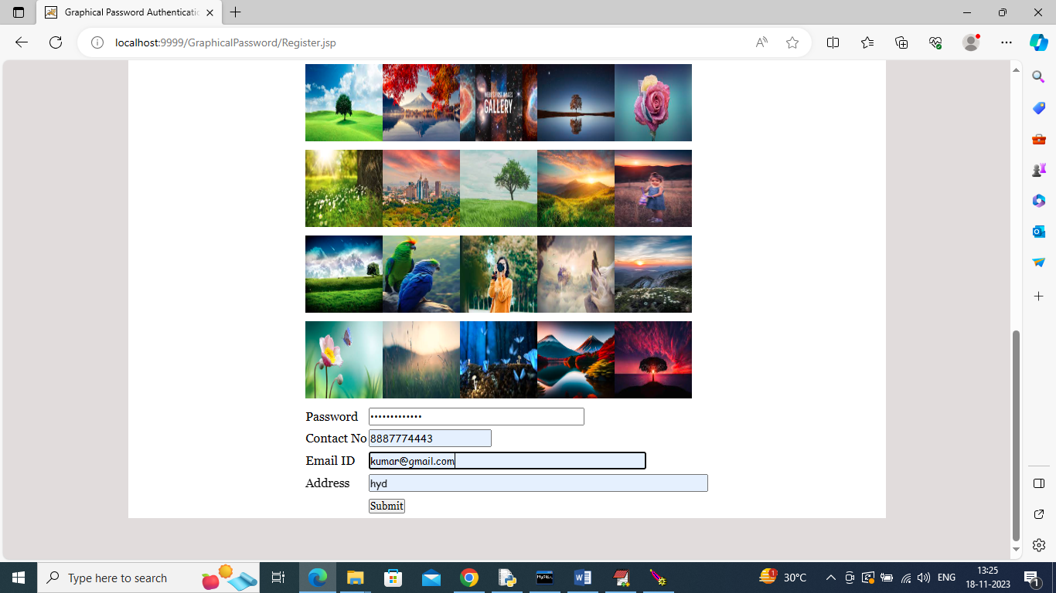

In above screen password will be generated automatically when you clicked on image and then enter remaining details and press button to get below page

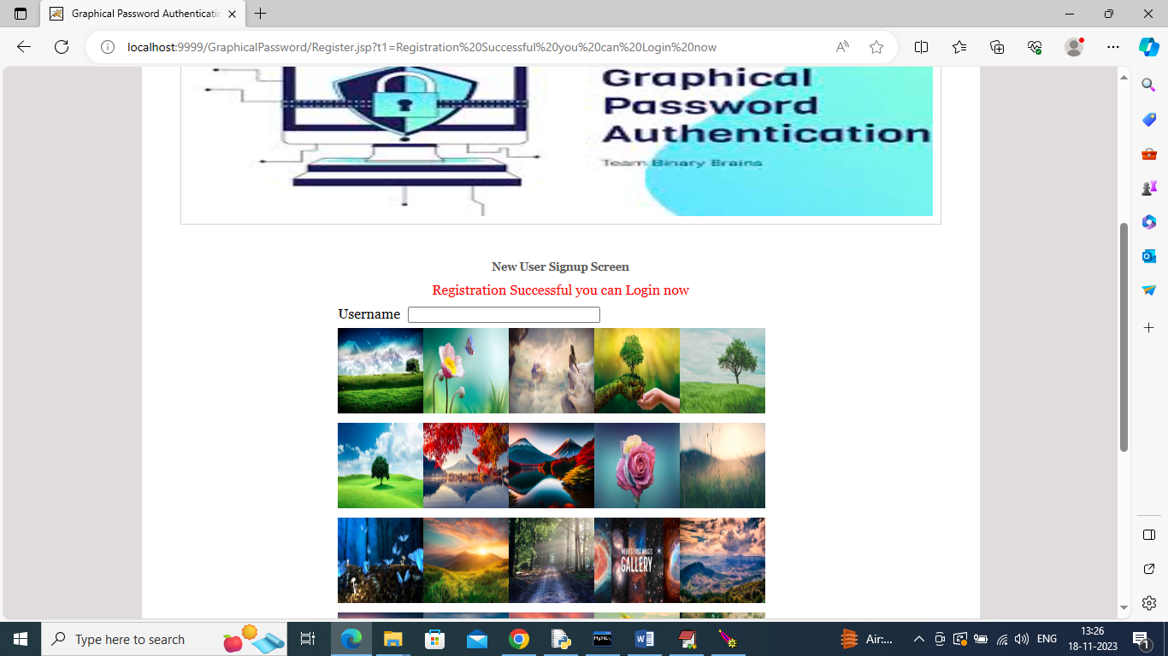

In above screen in red colour text can see Registration successful and now click on ‘User Login Here’ link to get below page

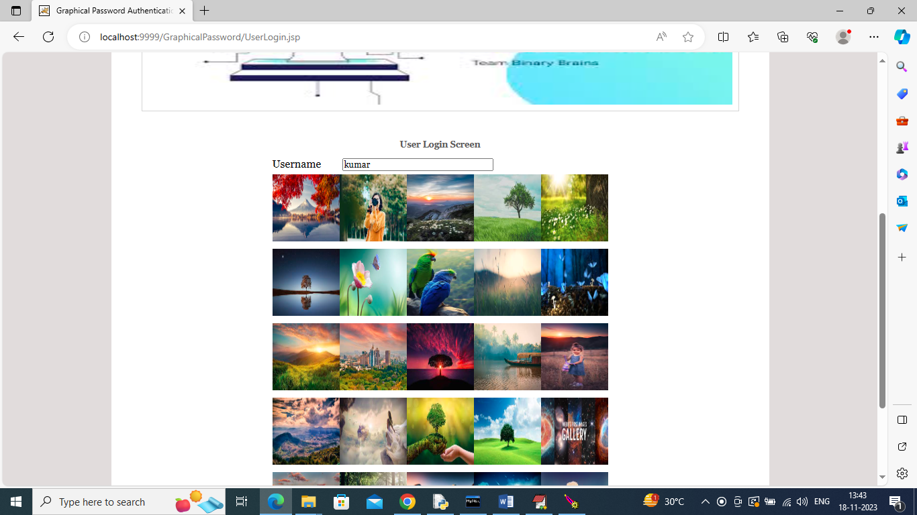

In above screen to login enter username and then click on correct image to generate password and then press login button like below screen

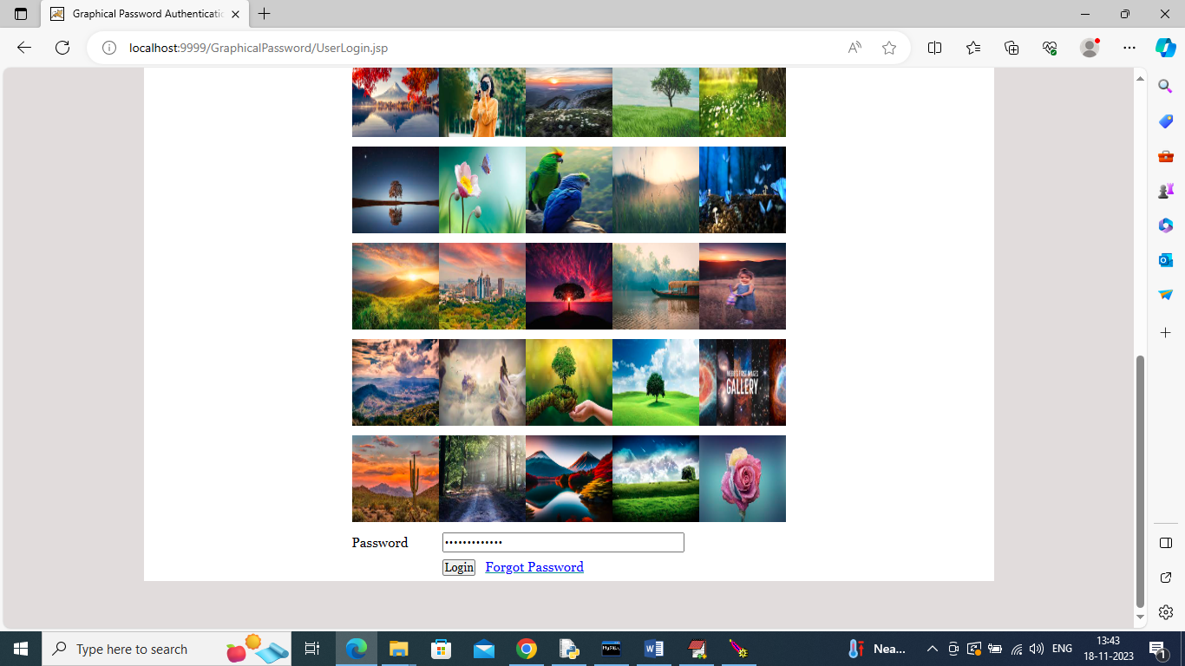

In above screen after clicking on image password is generated and now press ‘Login’ button to get below output

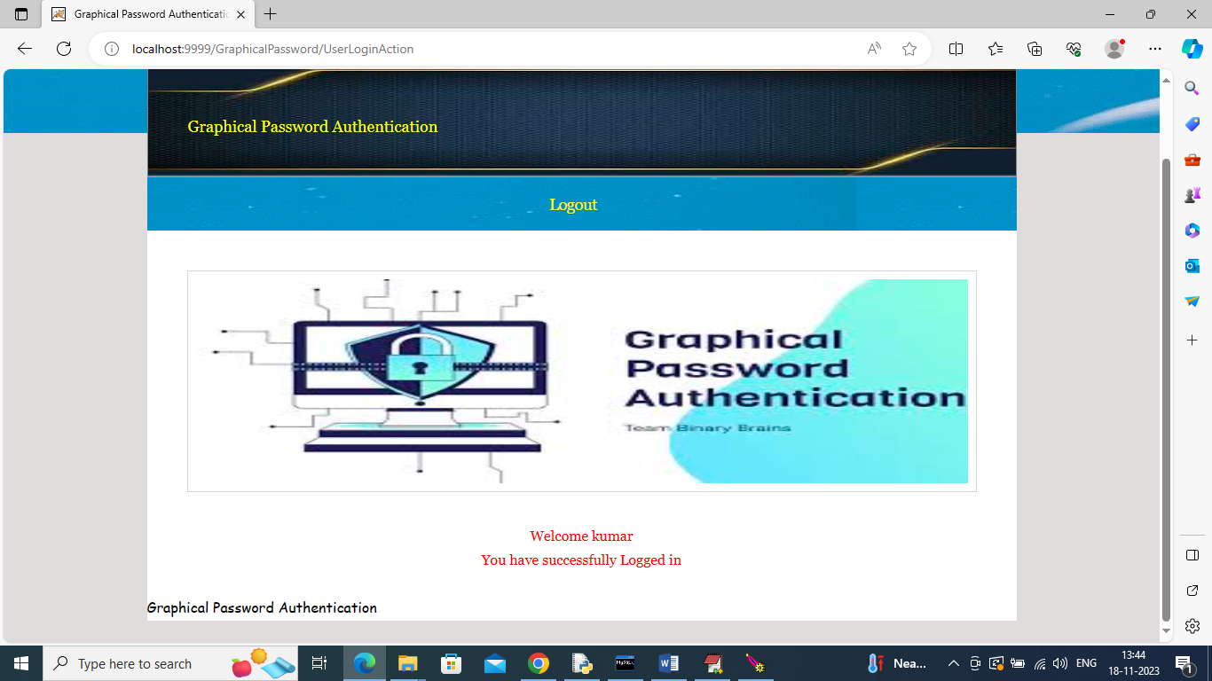

In above screen login is successful and similarly by following above screens you can generate image based password and now in below screen click on ‘Forgot Password’ to reset

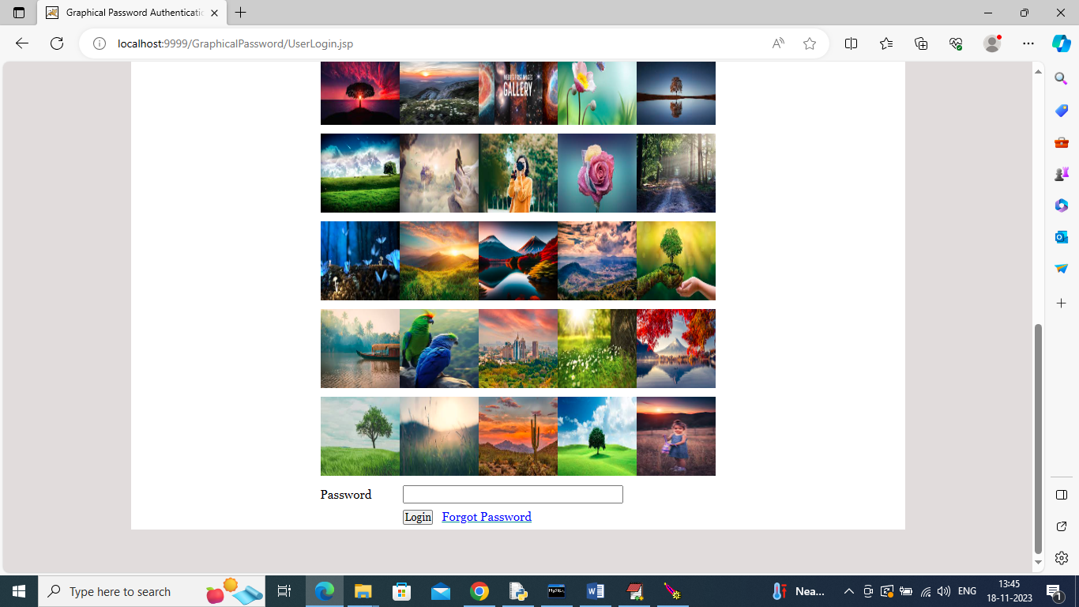

In above screen click on ‘Forgot Password’ link to get below page

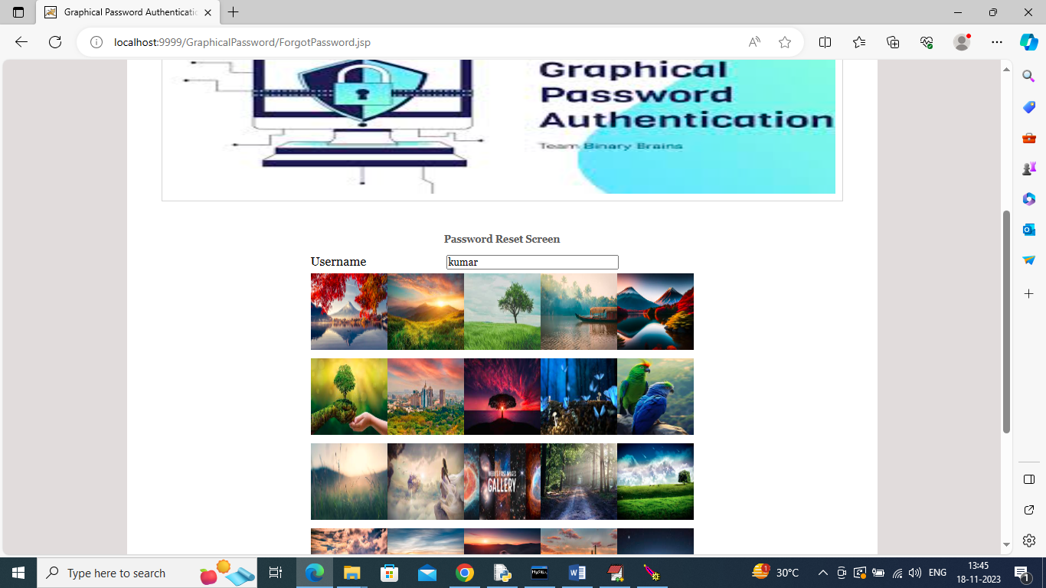

In above screen enter correct user name and then select new image as password to generate password to get below page

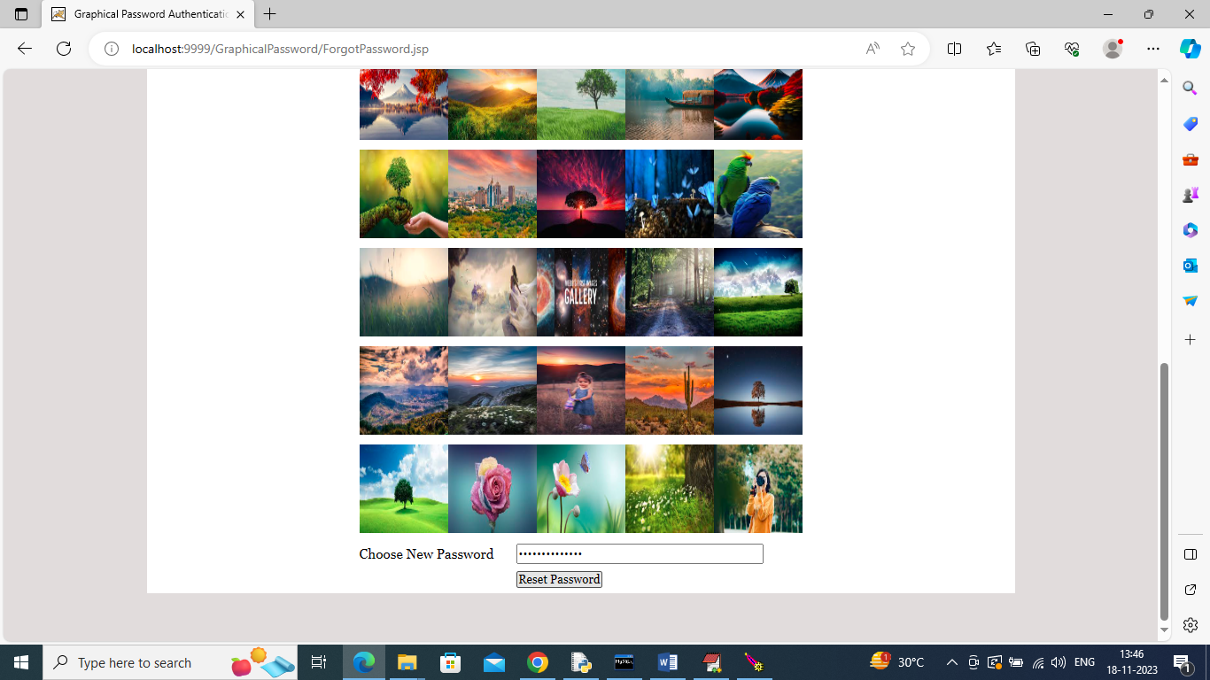

In above screen password is generate and now click on ‘Reset Password’ button to get below page

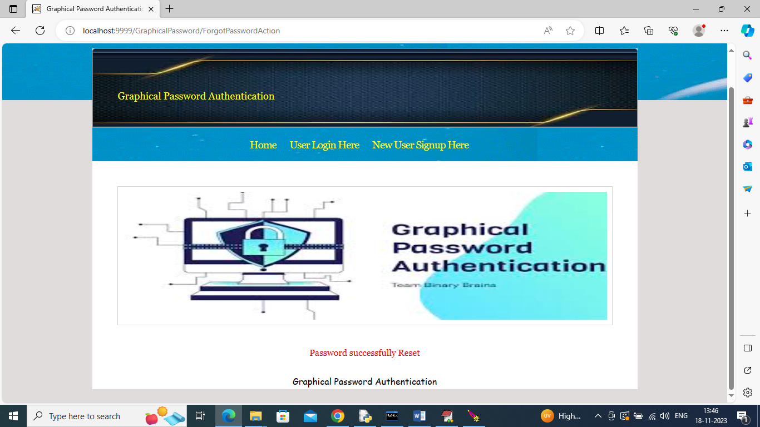

In above screen in red colour text can see new password is generated and similarly you can generate and resets passwords.

Note: by default password field is disabled mean you cannot type anything in password field and just you need to click on image to generate password